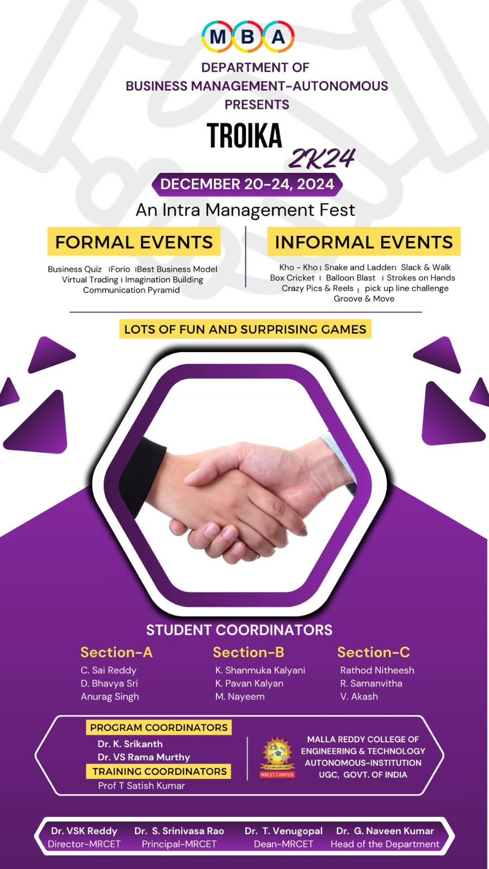

**VIRTUAL TRADING**

**Instructions to the Participants**

**Exam Time:** You have **20 minutes** to complete the Exam. Use your time carefully.

**Total Questions**: The Exam consists of **25 questions**. Read each question carefully before answering.

**Scoring System**: Each question carries **1 mark**, no negative marking.

**Submission**: Ensure that you submit your answers before the allotted time ends.

**TEAM NO._______**

|  |  |
| --- | --- |
| Name | Roll No. |
|  |  |
|  |  |
|  |  |

1. How many stocks are included in the index of Sensex? ( )

A) 30 B) 50 C) 111 D) 25

2.Who manages NIFTY 50. ( )

A) NSE Indices LTD B) BSE Indices LTD C) SEBI D) RBI

3.What is the currency of Kazakhstan? ( )

A) Som B) Tenge C) Kip D) Kwacha

4.In India, the chit funds are regulated by? ( )

A) Local Bodies B)RBI C)Central government D)State government

5.In forex trading PIP stands for ( )

A) Price in points B) Percentage increase potential

C) Profitable investment position D) Point of interest payments

6.Where is the New York stock exchange located ( )

A) Broadway B) Wall street C) Empire state building D) Times square

7. When was NSE established ( )

A)1996 B)1952 B)1965 D) none of these



8.The share price decided by (daily price changes) ( )

A) Stock exchange management B) Companies C) Central government D) RBI

9.When was Bitcoin first released. ( )

A) 2006 B)2009 C)2012 D)2015

10.What is an Index fund. ( )

A) A fund that replicates the performance of a specific Index

B) A fund that invest in bonds

C) A fund that invests in real estate

D) A fund that trades commodities

11. SEBI is statutory body, is it true or false? ( )

A) True B) False

12. You can Buy or Sell gold in equity market. ( )

A) True B) False

13. The dividend on a share is calculates on ( )

A) Redemption value B) Face value C) Market value D) Any of these

14. Find the odd one from the following ( )

A) RBI B) ICICI C) HDFC D) SBI

15. In markets, bulls represents, ( )

A) Flat Market B) Increasing Markets c) Declining Markets D) All are correct.

16. Finance minister of India is___________________

17. Who is the Chairman and MD of TATA group? ______________________________

18. Who is the brand ambassador of RADO watches in India? ____________________

19. ATM stands for:

20. In economic context NNP stands for?

21. Who introduced credits cards in India? Name the RBI Governor ______________

22. What is the closing value of NIFTY on 19.12.2024? ______________

23. Write the acronym of NABARD stands for____________________

24. SEBI stands for________________________

25. In investments S.I.P stands for?